Explicit Language and the Next Gen. Conversations: Albany at Tech.

Sarma Ramaswamy¹, Thomas C. Bishop², Kelly M. Thayer^{3,} Robert Young⁴
1 Department of Chemistry, University at Albany, Albany, NY 12222
2 Department of Physics, Louisiana Tech University, Ruston, LA 71270
3 College of Integrative Sciences, Wesleyan University, Middletown, CT 06459
4 Rutgers University, New Brunswick, NJ 08901

(318) 257-5209 bishop@latech.edu
(123) 555-1212 kthayer@wesleyan.edu
(321) 555-1212 ryoung.2011@rutgers.edu

Keywords: guidelines, abstract, author instructions

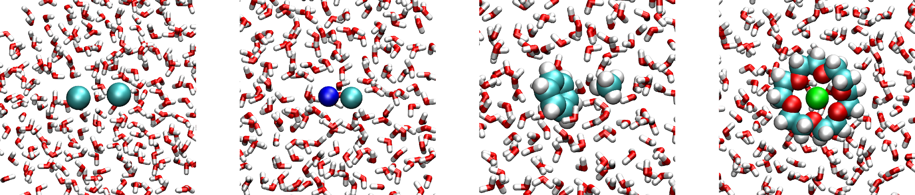
Figure: Image used in the previous abstract template.

This is the required format for the abstract. It is restricted to 350 words and approximately ½ page in final published form. It must not exceed 1 page when formatted as per this template.
The abstract should clearly state the motivation and/or background for the research, the method(s) used, the results obtained, and the significance of the work. All text and images from this template, including the acknowledgment, grant support, and references, should be replaced in your abstract.

Contact information (at least the email) for the corresponding author should be provided. Contact information for all authors may be provided if desired. The font should be Arial and no smaller than 11pt. The margins should be at least 0.50 inches on all sides. Images, equations, special characters, etc..must follow author guidelines for JBSD at
https://www.tandfonline.com/action/authorSubmission?show=instructions&journalCode=tbsd20
Acknowledgments: Bishop, Thayer and Young are grateful to Prof. Sarma Ramachandran for establishing the Conversations. We are eager to carry on the tradition and hope we can do justice to his efforts.

Funding: This research received support from NSF Award XYZ-123456.

References
K. A. Henzler-Wildman, K. A. & Kern. D. (2007). Dynamic personalities of proteins. Nature 450, 964-972.
G. A. Huber, G. A. & Kim, S. (1996). Weighted-ensemble Brownian dynamics simulations for protein association reactions. Biophys J 70, 97-110.
M. C. Zwier, M. C. & Chong, L. T. (2010). Reaching biological timescales with all-atom molecular dynamics simulations. Curr. Opin. Pharmacol. 10, 745-752.

